Modul Number: 0750362
Module Name: Database Applications

Teacher: Eman Alnaji

Part V
PL/SQL (Cont.)

Exceptions (Cont.):
Undefined Exceptions:
- Less-common errors that have not been given predefined names
- ORA- error code appears
- Exception handler tests for ORA- error code and provides alternate error message
User-Defined Exceptions:
- Errors that will not cause a run-time error, but will violate business rules
(i.e. they are created for logical errors)
- Programmer creates a custom error message
Example of a User-Defined Exception:
Declare
huge_quantity exception; -- Declaration of the exception
V_qty number(10);
v_msg varchar2(100);
Begin
v_qty := &V_qty; -- Here this value is requested from the user
if v_qty > 1000 then
v_msg := ‘very huge quantity’;
raise huge_quantity; -- Raising the exception huge_quantity
else
v_msg := ‘Good’;
end if;
dbms_output.put_line (v_msg);
Exception
when huge_quantity then -- Handling of exception huge_quantity
dbms_output.put_line (v_msg);
End;

Using an error number for a User-Defined Exception:
- Oracle provides the numbers from -20000 to -20999 to User-Defined Excpetions.
- In the previous example, you can handle the huge_quantity exception using an error number.
Exception
when huge_quantity then
raise_application_error (-20100, v_msg);
End;

Nested PL/SQL Program Blocks
- An inner program block can be nested within an outer program block
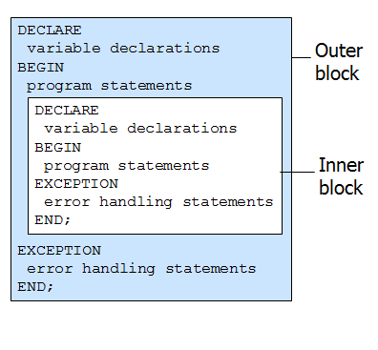
Exception Handling in Nest Program Blocks
- If an exception is raised and handled in an inner block, program execution resumes in the outer block
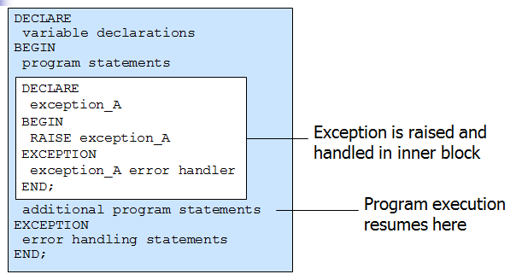
- Exceptions raised in inner blocks can be handled by exception handlers in outer blocks
Advanced PL/SQL Programs

Anonymous PL/SQL Programs
- PL/SQL blocks that we have written so far.
- Write code in text editor, execute it in SQL*Plus
- Code can be stored as text in file system
- Program cannot be called by other programs, or executed by other users
- Cannot accept or pass parameter values
Named PL/SQL Programs
- Can be created:
  - Using text editor & executed in SQL*Plus
  - Using Procedure Builder (an application installed within Oracle Developer Package).
- Can be stored:
  - As compiled objects in database
  - As source code libraries in file system
- Can be called by other programs
- Can be executed by other users
Named Program Locations
- Server-side
  - Stored in database as database objects
  - Execute on the database server
- Client-side
  - Stored in the client workstation file system
  - Execute on the client workstation
Named Program Types
- Program Units
  - Procedures
  - Functions
- Packages
- Triggers
Program Units
- Procedures
  - Can receive and pass multiple parameter values
  - Can call other program units
- Functions
  - Like procedures, except they return a single value
Parameters
- Variables used to pass data values in/out of program units
- Declared in the procedure/function header
- Parameter values are passed when the procedure/function is called from the calling program
Parameter Modes
- IN
  - Incoming values, read-only (default)
- OUT
  - Outgoing values, write-only
- IN OUT
  - Can be both incoming and outgoing
Procedures - Functions
Creating a Procedure
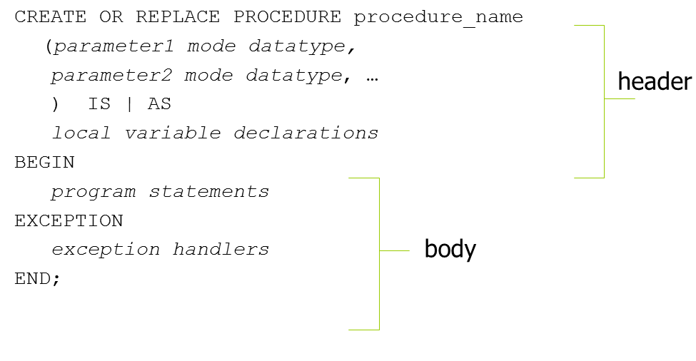
Executing a Procedure (in SQLPlus)
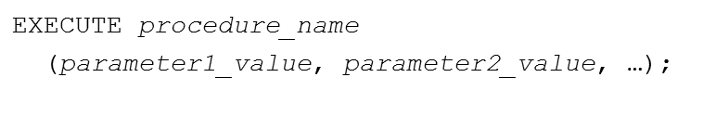
Calling a Procedure from another Procedure or Function
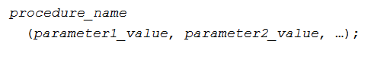
Parameter Types
- Formal parameters: declared in procedure header
- Actual parameters: values placed in parameter list when procedure is called
- Values correspond based on order
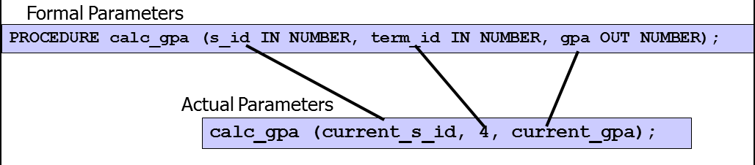
Dropping a Procedure
Creating a Function
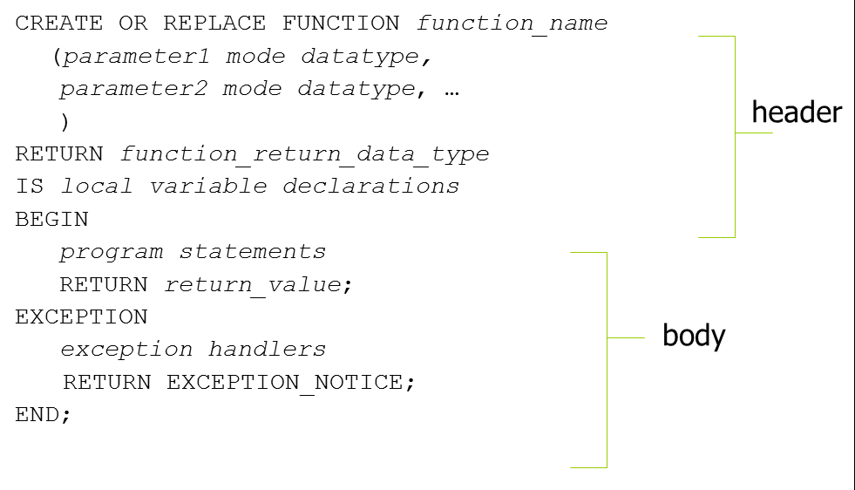

Function Syntax Details
- RETURN command in header specifies data type of value the function will return
- RETURN command in body specifies actual value returned by function
Calling a Function
- Can be called from either named or anonymous PL/SQL blocks
- Can be called within SQL queries
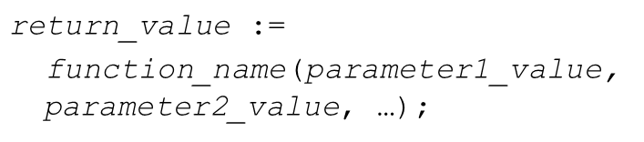
Note: return_value should be a declared variable.
Example1:
Create a procedure that prints all employees for a given department number.
CREATE OR REPLACE PROCEDURE Get_emp_names (V_dno IN NUMBER)
IS
Emp_name VARCHAR2(30);
CURSOR c1 IS
SELECT fname FROM employee
WHERE dno = v_dno;
BEGIN
OPEN c1;
LOOP
FETCH c1 INTO Emp_name;
EXIT WHEN C1%NOTFOUND;
DBMS_OUTPUT.PUT_LINE(Emp_name);
END LOOP;
CLOSE c1;
END;
Execution:
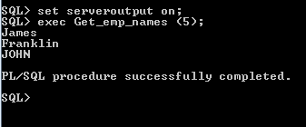
Example2:
Assuming that the salary field in table employee stores the annual salary of an employee, create a function that returns the monthly salary of a given employee.
CREATE OR REPLACE FUNCTION Mon_Sal (v_ssn employee.ssn%type)
RETURN NUMBER
IS
Monthly_sal NUMBER(10,2);
BEGIN
SELECT round (salary/12)
INTO Monthly_sal
FROM Employee
WHERE ssn = v_ssn;
RETURN (Monthly_sal);
END;
/
Execution:
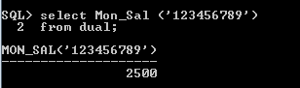

Packages
- Can contain:
  - Global variable declarations
  - Cursors
  - Procedures
  - Functions
Package Components
- Specification
  - Used to declare all public variables, cursors, procedures, functions
- Body
  - Contains underlying code for procedures and functions
Creating a Package Specification in SQL*Plus
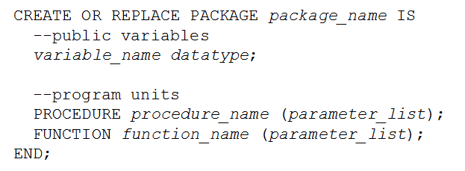
Creating a Package Body in SQL*Plus
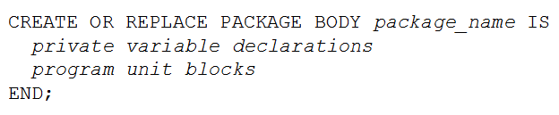
Calling a Program Unit That Is In a Package
Example:
